Accessible Educational Materials Report Setup Guide
  - October 2026

Introduction
This setup guide serves as the reference document for the Accessible Educational Materials (AEM) Report, a Power BI report designed to connect to a state's Common Education Data Standards (CEDS) Data Warehouse. The report enables State Education Agencies (SEAs) and Local Education Agencies (LEAs) to analyze data related to accessible educational materials for students with disabilities who require them. By identifying gaps in data collection and providing actionable insights, the report supports data-driven decision-making that improves the provision, delivery, and use of accessible educational materials.

Background
This report leverages five previously developed CEDS connections, which aim to standardize data collection in areas where SEAs, LEAs, and schools are not currently required to collect data. Although these data elements are not universally required, the CEDS connections and corresponding Power BI report are intended to encourage the collection and analysis of information related to accessible educational materials and technologies.
The report supports the examination of policy questions, identification of data gaps, and analysis of disparities and barriers that may affect access to accessible educational materials and technologies. These insights can help stakeholders make informed, data-driven decisions to improve access to the resources students need to succeed.
The following CEDS connections are leveraged by this report:
- Does the Student with a Disability Require Accessible Format(s)?
- Number of Students with Disabilities Issued Accessible Formats
- Process by Which Accessible Formats are Provided to Students with Disabilities
- Provision of Accessible Formats in a Timely Manner
- What Type of Accessible Format(s) Does a Student with a Disability Require?

Prerequisites
- This report requires states to be users of CEDS Data Warehouse.
- The latest version of Power BI Desktop
- Access to the CEDS Data Warehouse
- VPN Access if required

Preparing CEDS Data Warehouse
The Accessible Educational Materials report uses stored views of data in the Reporting Tables. These views are available with the latest version of Generate.
The views contain fact and dimension table IDs that are joined with other fact and dimension tables within the data warehouse to return other data elements used within the BI report.

The Required View
Listed below is a custom view created specifically for this report:
- vwAccessibleEducationMaterialAssignments
  - Description: All students that are enrolled in a school for the report year with either an IEP/504, are in grades PK through 12 and are between the ages 3-21.
  - Primary Field:
    - Fact.K12StudentId

Adding the Views
To add the required views, download the ‘vwAccessibleEducationMaterialAssignments.txt’ file from the “SQL Views” folder in GitHub.
Open each view in your SQL Management Studio (or similar) open and execute the view into your copy of the data warehouse. This will add the required views.
If you change the name, field names, or the values returned, you will need to update the BI tool to reflect the changes.
*The views will be added by default in Generate 14.1.

Connecting the report to the source
The .pbix file with a copy of the report is available in the CEDS Collaborative Exchange’s GitHub folder: https://github.com/CEDS-Collaborative-Exchange/AEM-Center-Reports
The downloaded report contains cached test data and is not intended to represent any actual state data. To use the report with your state’s data, you will need to connect the provided report template (.pbix) with your instance of the CEDS Data Warehouse.
Remember to connect to the VPN if required by your network administrators.

Steps
- Download the .pbix file and open it in your Power BI Desktop environment. After the initial download, the report will contain cached sample data for demonstration purposes.
- To use your data in the report, connect it to the CEDS data warehouse. Click ellipses dropdown on the ‘Home’ tab. Select ‘Transform data’ under the ‘Queries’ section then select ‘Data source settings’.

- Next click ‘Change Source...’.
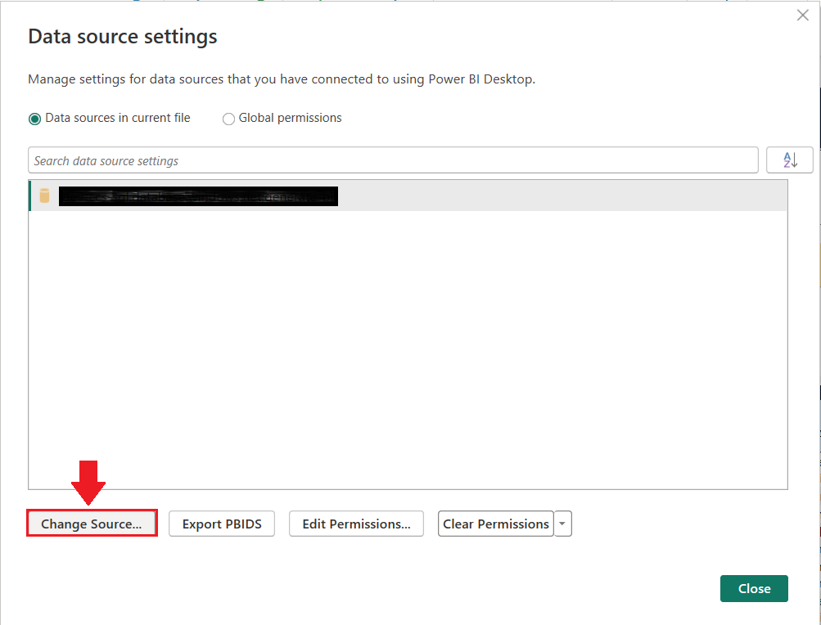

- Populate the ‘Server’ and ‘Database’ fields with your CEDS data warehouse’s server name and database name. Click ‘OK’.
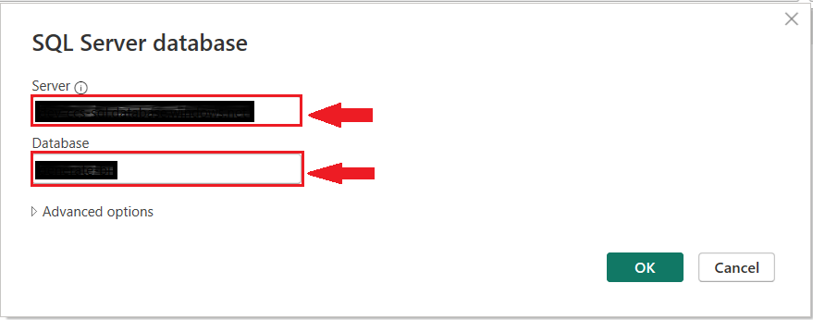
Your report will now refresh and load data from the CEDS Data Warehouse. During this process, the data is cached locally within the .pbix file. Depending on the size of your dataset, the refresh may take several minutes to complete.

Distribution
This report contains student identification numbers and other personally identifiable information (PII). Access to the report should be limited to authorized individuals in accordance with your SEA's data governance, privacy, and security policies. Before sharing the report, review and follow all applicable state policies and procedures regarding the handling of sensitive student data.

Although the .pbix file can be distributed to users with Power BI Desktop, it is recommended that the report be published and shared through an internal Power BI Workspace. Sharing the report through a Power BI Workspace provides greater control over user access, helps prevent unauthorized modifications to the report, and supports additional distribution options, such as embedding the report in a Microsoft Teams channel or other approved mechanisms.

Steps
- To share through an online workspace, sign into office.com and select ‘Power BI’ from the menu icon. In Power BI, create a new workspace by adding the required information.
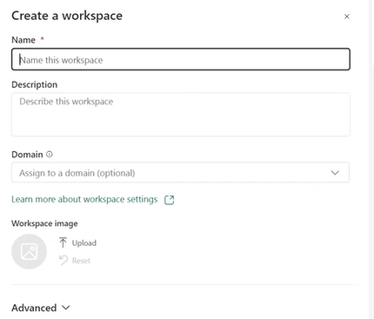

- Once the workspace is created, upload the .pbix file to the workspace.
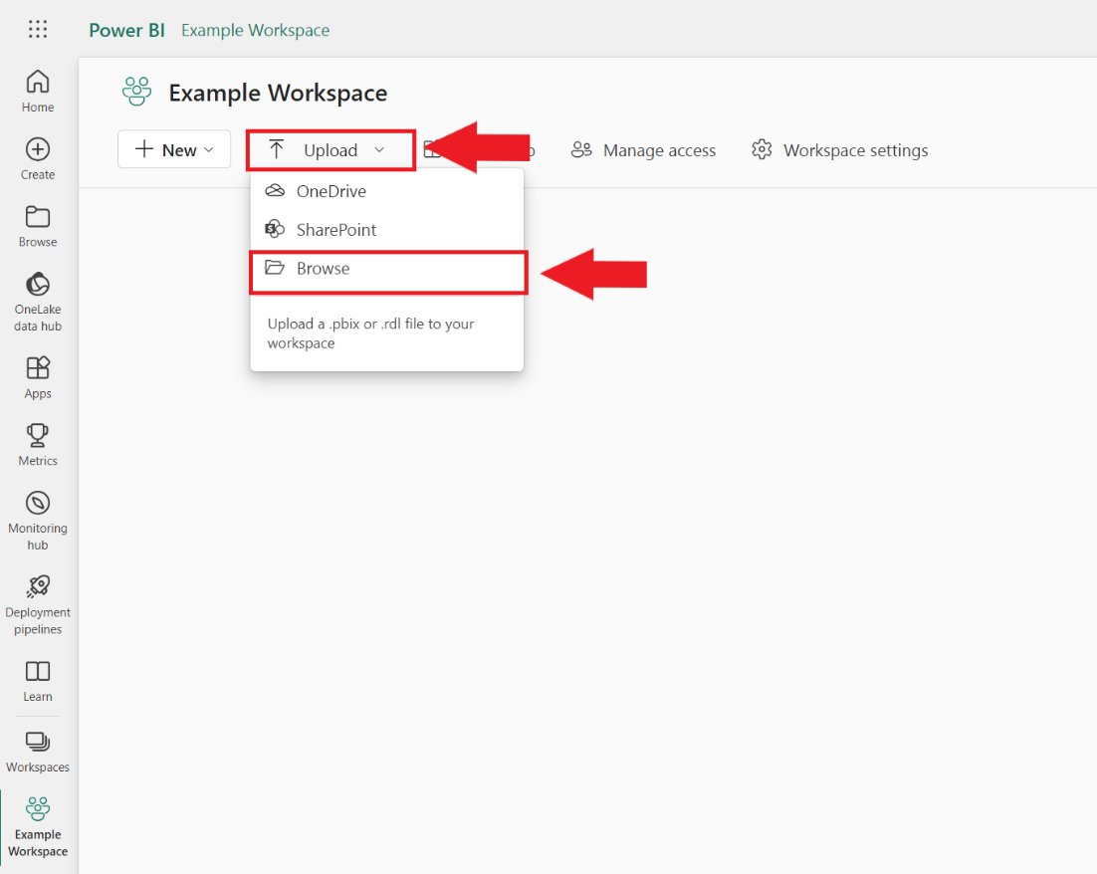

- After the report is uploaded in the workspace, the dashboard will be available to use and share by clicking on the report.
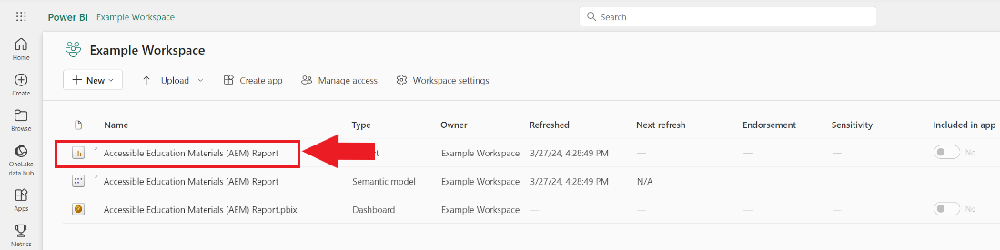

- Once you have navigated to the report, select ‘Share’ to manage access and grant permissions to authorized individuals within your organization.
- Type in the name of the person you want to share with. Then click the method you would like to send through.

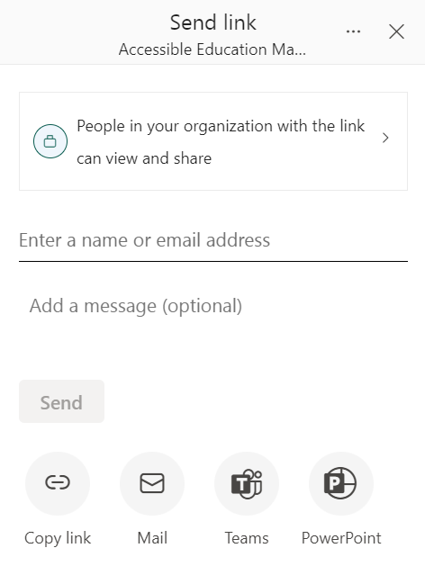

Data Refresh
Administrators of the report can refresh the data in two different ways:
- If using the report as a desktop .pbix file, click the refresh button to view updated data.
  - If this report is being used in the workspace, after refreshing data, then click publish to allow authorized users to view the data.
- To refresh from workspace, go to the semantic model and click the refresh button.
